BiSS Interface Master Chip with SPI and RS-422 Transceiver in Space-Saving Package
Highlight at SPS 2025 (Hall 4A, Booth 146)

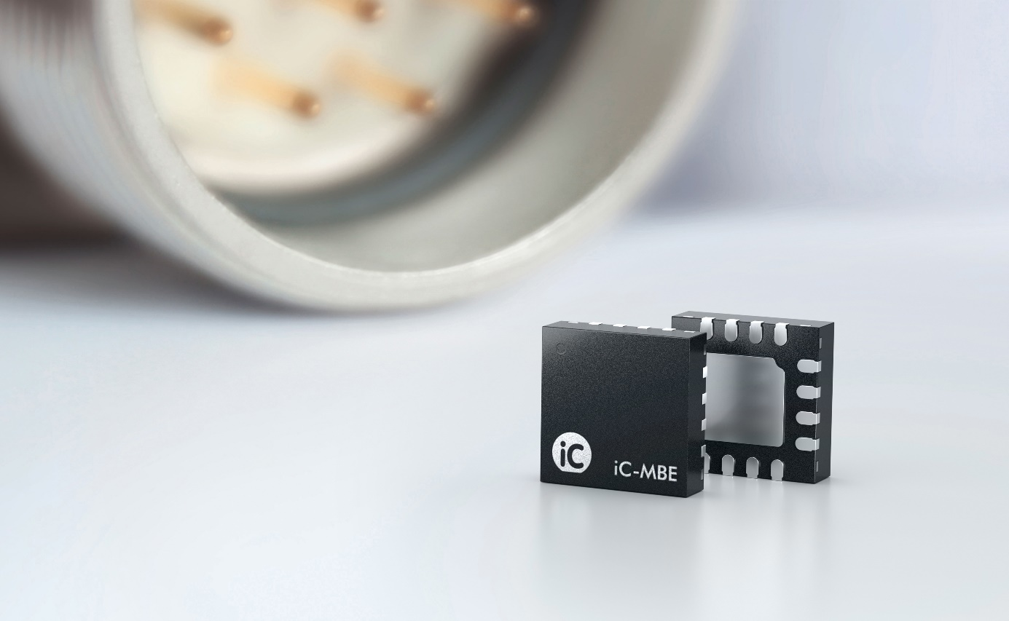
Image: iC-Haus GmbH

Bodenheim, November 2025: iC-Haus presents the iC-MBE, a high-performance BiSS Interface Master implementation with on-chip RS-422 transceiver and 20 Mbit/s SPI. This compact SPI-to-BiSS converter has been designed to meet the demands of high-performance motor feedback applications such as drives, PLCs and robots.

The open BiSS Interface has become a popular global standard for high-performance motion control applications. The low-weight protocol enables fast isochronous data transmission between a control unit and sensors or actuators. Typically, it is used in motor feedback systems to transmit position data from an encoder to a drive. However, due to its versatility, the BiSS protocol is equally suitable for transmission of other sensor data such as temperature, acceleration or torque.
With iC-MBE, iC-Haus provides a ready-to-operate SPI-to-BiSS Master converter that simplifies implementation of the BiSS and SSI Interface in arbitrary platforms such as drives, PLCs and robots. iC-MBE has an on-chip RS-422 transceiver which complies with the typical electrical specification in BiSS/SSI systems.
Modern motion control systems with condition monitoring and predictive maintenance benefit from a simple solution to acquire further sensor data without additional wiring.
iC-MBE relieves the controller with respect to the BiSS C protocol in point-to-point and bus topologies. Up to eight data channels for daisy-chained sensors and actuators can be enabled. Each data channel supports a data length of up to 64 bit and a CRC polynomial of up to 16 bit.
As an alternative to the internal RS-422 transceiver, two single-ended TTL/CMOS interfaces can be used to enable simultaneous data acquisition from two BiSS sensors.

The controller can access iC-MBE via SPI with up to 20 Mbit/s to control the BiSS communication and exchange process data so that BiSS cycle times way below 10 µs can be achieved. Due to the precise internal oscillator, an external standard oscillator is dispensable.
With its 3x3mm² package, iC-MBE is the perfect ready-to-operate solution for compact BiSS/SSI Master implementations.

Further information on the iC-MBE:
https://www.ichaus.de/product/ic-mbe/

