Rotary Encoders and Motor Feedback Systems:
The New System-on-Chip for Optical Absolute Encoders

Highlight at SPS 2025 (Hall 4A, Booth 146)
The iC-RT2624 from iC-Haus is the new System-on-Chip for optical absolute encoders. Its powerful interpolation circuit detects the angle of a code disc with 26-bit resolution. Thanks to contamination-tolerant scanning and high mounting tolerances, the iC-RT2624 is ideal for housed and kit encoders.

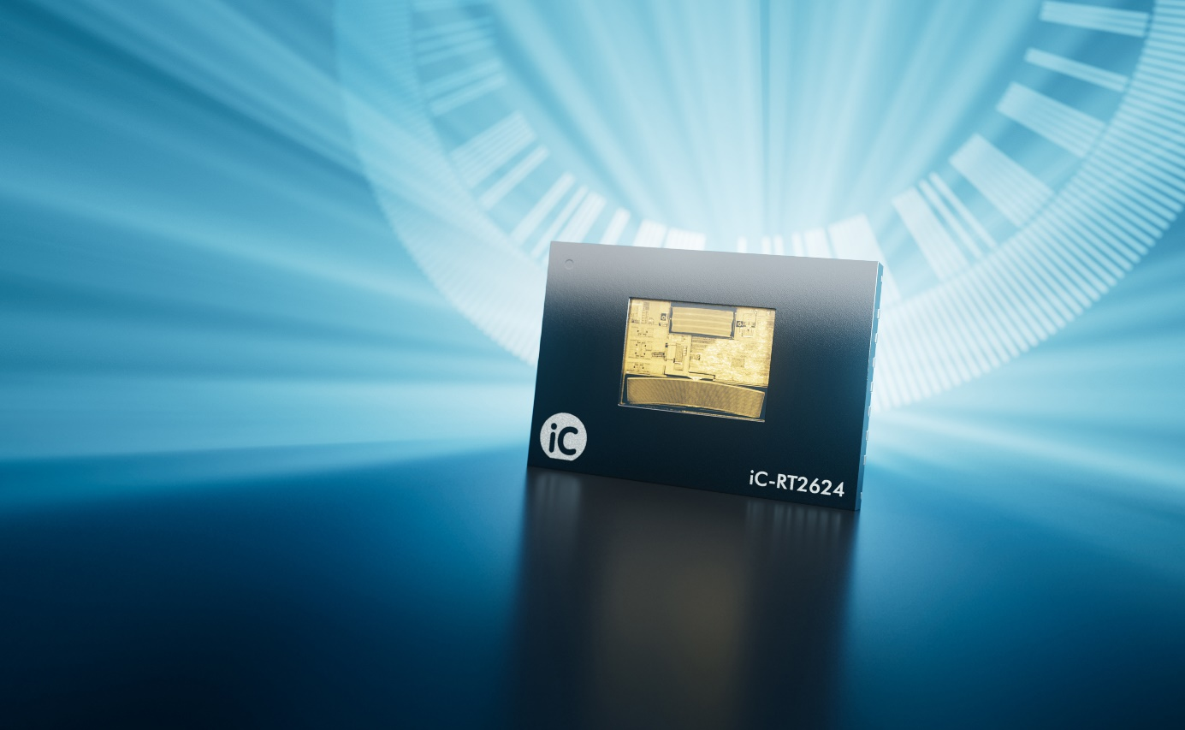
Image: iC-Haus GmbH

Bodenheim, October 2025: Precise, innovative, and flexible in application: that is the new System-on-Chip (SoC) for optical absolute encoders from iC-Haus. The iC-RT2624 impresses with state-of-the-art photodetectors and robust, contamination-tolerant scanning. The microelectronics integrated in the compact 7 mm x 5 mm optoQFN package delivers accurate measurements within high mounting tolerances. The powerful interpolation circuit with filtering at the heart of the system reliably detects the angle of a 26 mm code disc with 26-bit resolution, even in demanding, dynamic applications. Digitized angle information is available to the BiSS, SSI, or SPI serial interfaces in less than one microsecond. A programmable ABZ generator with FlexCount® quadrature resolution easily adapts to any controller and provides sharp edges for excellent control quality.

Thanks to auto-calibration and eccentricity compensation, encoder systems with the iC-RT2624 easily achieve an angular accuracy of less than 0.01°. On-chip calibration can be performed via the BiSS and SPI serial interfaces or at the push of a button. This simplifies the production of encoder systems and saves time when commissioning modular kit encoders. The dimensions of the code disc can be freely adjusted with a FlexCode® design starting at an outer diameter of 20 mm. This allows compact motor feedback and larger hollow shaft encoders to be developed with the same sensor.
Another new feature is the programmable sin/cos generator, which can be set to 2^{n} CPR (n = 0..15) regardless of the base resolution of the code disc. The native sin/cos resolution is simultaneously available for output and routed through a separate, safety-ready signal path. The integrated Absolute Data Interface (ADI) completes the diverse interfaces of this flexible sensor platform and is compatible with established multiturn sensors from iC-Haus, such as the battery-buffered iC-PVL, the gear scanner iC-MV, or energy harvesting systems with Wiegand wire.
The iC-RT2624 can be operated within 3.0 V to 5.5 V and is sensitive to blue, red, and infrared light. The LED control integrated in the chip adjusts the illumination for an optimal operating point. The encoder SoC is suitable for an operating temperature range of -40 °C to 125 °C. A comprehensive monitoring and diagnostic architecture constantly checks the operating conditions. For instance, a digital contrast measurement detects when condensation or precipitation from outgassing ball bearing grease impairs the optical projection before the angle detection is critically disrupted – for permanent condition monitoring.

Further information on the iC-RT2624:
https://www.ichaus.de/product/ic-RT2624

